

Metreos ActiveRelay

User Guide
Metreos Communications Environment 2.1.4

Information in this document is subject to change without notice.

Copyright © 2005 Metreos Corporation. All rights reserved. Metreos trademarks marked with ® or © herein are registered or protected trademarks of Metreos in the U.S. and foreign countries. All other trademarks in the document are the property of their respective owners.
Licensing Terms
Use of this Software is subject to license restrictions. Carefully read this license agreement before using the software.
This End User License Agreement (the “Agreement”) is a legal agreement between you, either individually or as an authorized representative of the company or organization acquiring the license, and Metreos Corporation (“Metreos”). USE OF SOFTWARE INDICATES YOUR COMPLETE AND UNCONDITIONAL ACCEPTANCE OF THE TERMS AND CONDITIONS SET FORTH IN THIS AGREEMENT. If you do not agree to these terms and conditions, promptly return or, if electronically received, certify destruction of the Software and all accompanying items within five days after receipt of Software and you will receive a full refund of the applicable license fees paid.
1. License Grant
a. The software programs you are installing, downloading, or have acquired with this Agreement, including any related equipment or hardware, documentation, updates, upgrades, modifications, revisions, copies and design data (“Software”) are copyrighted, trade secret and confidential information of Metreos and its licensors who maintain exclusive title to all Software and retain all rights not expressly granted by this Agreement. Metreos grants to you, subject to payment of appropriate license fees, a non-exclusive, non-transferable, internal-use only, term license to use the Software owned or distributed by Metreos in machine readable, object-code form on the computer hardware or at the site(s) for which an applicable license fee has been paid, as authorized by Metreos.
b. To the extent that you design applications that operate on the Metreos Communications Environment (the “MCE”), Metreos grants you a non-exclusive, non-transferable, internal-use only, term license to use the Software, including the MCE, for the purposes of operating such programs, subject to payment of appropriate license fees.
c. The license granted herein is contingent on your (or your organization’s) continued acceptance and subscription to the maintenance and support terms provided by Metreos. Termination by you or your organization of ongoing maintenance and support requirements terminates the license granted herein.
2. Restrictions and Intellectual Property Ownership
a. You may not (i) remove or modify any notice of Metreos’ proprietary rights, (ii) re-license, rent, lease, timeshare, or act as a service bureau or provide subscription services for the Software, (iii) use the Software to provide third-party training, except for training agents and contractors authorized under this Agreement; (iv) assign this Agreement or give the Software or an interest in the Software to another individual or entity; (v) cause or permit reverse engineering or decompilation of the Software; (vi) disclose results of any Software benchwork tests without Metreos’ prior written consent; or (vii) modify the Software or any portions thereof without Metreos’ prior written consent.
b. The Software, which is copyrighted, and any modifications, upgrades, or updates thereto, is the sole and exclusive property of Metreos and is a valuable asset and trade secret of Metreos. Metreos retains all ownership and intellectual property rights to the Software and to any modifications, upgrades, or updates thereto. Except for the rights granted in herein above, you shall have no right, title, or interest of any kind in or to the Software.
c. Metreos may audit your use of the Software. If Metreos gives you or your organization reasonable advance written notice, you agree to cooperate with the audit, and to provide reasonable assistance and access to information. You agree to immediately remit any underpaid license and technical support fees determined as the result of such audit.
3. Term and Termination.
a. This Agreement remains effective until expiration or termination. This Agreement will immediately terminate upon notice if you exceed the scope of the license granted or otherwise fail to comply with the provisions in sections 1 and 2 above. For any other material breach of the Agreement, Metreos may terminate this Agreement if you are in breach and fail to cure the breach within thirty (30) days of written notification. If Software is provided for a limited term use, this Agreement will automatically expire at the end of the authorized term.
b. Upon termination of this Agreement for any reason, you shall within ten (10) business days return to Metreos all Software Additionally, you agree to delete from any permanent machine storage (i.e., hard disk) previously loaded copies of the Software in all forms. Upon request of Metreos, you shall certify in writing that all copies of the Software and associated documentation have been destroyed or returned to Metreos. The indemnity and limitation of liability obligations hereunder, as well as your obligations with respect to confidential treatment of the Software and Metreos’ trade secrets, other intellectual property, and proprietary information, shall survive the termination of this Agreement.
4. Limited Warranty.
a. Metreos warrants that the Software will substantially operate as described in the applicable Software documentation for ninety (90) days after Metreos delivers it to you. THE WARRANTY HEREIN IS EXCLUSIVE AND IN LIEU OF ALL OTHER WARRANTIES, WHETHER EXPRESS OR IMPLIED, INCLUDING THE IMPLIED WARRANTIES OF MERCHANTABILITY AND FITNESS FOR A PARTICULAR PURPOSE. METREOS MAKES NO WARRANTY THAT ANY SOFTWARE WILL PERFORM ERROR-FREE OR UNINTERRUPTED, OR THAT ALL ERRORS THEREIN CAN OR WILL BE CORRECTED. METREOS FURTHER DISCLAIMS ANY IMPLIED WARRANTIES ARISING FROM COURSE OF PERFORMANCE, COURSE OF DEALING OR USAGE OF TRADE.
b. For any breach of the above warranty, Metreos’ entire liability and your exclusive remedy shall be, at Metreos’ option, either (1) refund of the fees paid upon return of the Software to Metreos, or (2) correction or replacement of the Software that does not meet this limited warranty, provided you have complied with the terms of this Agreement.
5. Indemnity
a. Metreos will defend and indemnify you against a claim that any Software, infringes a patent or copyright, provided that: (i) you notify Metreos in writing within thirty (30) days of the claim; (ii) Metreos has sole control of the defense and all related settlement negotiations; and (iii) you provide Metreos with the assistance, information, and authority reasonably necessary to perform the above; reasonable out-of-pocket expenses incurred by you in providing such assistance will be reimbursed by Metreos.
b. Metreos shall have no liability for any claim of infringement resulting from: (i) your use of a superseded or altered release of the Software if infringement would have been avoided by the use of a subsequent unaltered release of the Software which Metreos provides to you; or (ii) any information, design, specification, instruction, software, data, or material not furnished by Metreos or (iii) any combination of the Software with other hardware, software or processes that, but for the combination, the Software would not be infringing.
c. In the event that some or all of the Software is held or is believed by Metreos to infringe, Metreos shall have the option, at its expense: (i) to modify the Software to be non-infringing; or (ii) to obtain for you a license to continue using the Software. If it is not commercially feasible to perform either of the above options, then Metreos may require from you return of the infringing Software and all rights thereto. Upon return of the infringing Software to Metreos, you may terminate the Agreement with ten (10) days’ written notice and you shall be entitled to a pro-rata refund of the fees paid for the infringing Software. This subsection sets forth Metreos’ entire liability and exclusive remedy for infringement.
d. You will defend and indemnify Metreos and its licensors against any claim incurred by, borne by or asserted against Metreos or its licensors that relates to or results from (i) your use of the Software, (ii) any intentional or willful conduct or negligence by you or (iii) any breach of an applicable representation, covenant or warranty contained herein.
e. Should the party seeking indemnification (“Indemnitee”) reasonably determine that the party from whom indemnity is sought (“Indemnitor”) has failed to assume the defense of any claim referenced herein, Indemnitee shall have the right to assume such defense and have all expense and cost of the defense reimbursed by Indemnitor, including reasonable attorneys fees.
6. Confidentiality
The Software contains proprietary and confidential information of Metreos as well as trade secrets owned by Metreos. You agree to hold the Software in strict confidence and not to disclose the Software in any way except as expressly permitted hereunder. You agree to protect the Software at least to the same extent that you protect your similar confidential information, but in no event less than reasonable care. You further agree that you will not, directly or indirectly, copy the structure, sequence, or organization of the Software, nor will you copy any portion of the Software or related documentation to produce software programs that are substantially similar to the Software.
7. LIMITATION OF LIABILITY
EXCEPT WHERE THIS EXCLUSION OR RESTRICTION OF LIABILITY WOULD BE VOID OR INEFFECTIVE UNDER APPLICABLE LAW, IN NO EVENT WILL METREOS BE LIABLE FOR ANY INDIRECT, INCIDENTAL, SPECIAL, OR CONSEQUENTIAL DAMAGES, OR DAMAGES FOR LOSS OF PROFITS, REVENUE, DATA, OR USE, INCURRED BY YOU OR ANY THIRD PARTY, WHETHER IN AN ACTION IN CONTRACT OR TORT, EVEN IF METREOS OR ANY OTHER PERSON HAS BEEN ADVISED OF THE POSSIBILITY OF SUCH DAMAGESMETREOS’ LIABILITY FOR DAMAGES HEREUNDER SHALL IN NO EVENT EXCEED THE AMOUNT OF FEES PAID BY YOU FOR THE SOFTWARE OR SERVICE GIVING RISE TO THE CLAIM. IN THE CASE WHERE NO AMOUNT WAS PAID, METREOS SHALL HAVE NO LIABILITY FOR ANY DAMAGES WHATSOEVER.
8. Assignment; Jurisdiction.
This Agreement will be binding upon, and will inure to the benefit of, the permitted successors and assigns of each party hereto. You may not assign, delegate, transfer, or otherwise convey this Agreement, or any of its rights hereunder, to any entity without the prior written consent of Metreos, and any attempted assignment or delegation without such consent shall be void. This Agreement, and all matters arising out of or relating to this Agreement, shall be governed by the laws of the State of Texas, United States of America. Any legal action or proceeding relating to this Agreement shall be instituted in any state or federal court in Travis or Dallas County, Texas, United States of America. Metreos and you agree to submit to the jurisdiction of, and agree that venue is proper in, the aforesaid courts in any such legal action or proceeding.
9. Severability; Waiver
In the event any provision of this Agreement is held to be invalid or unenforceable, the remaining provisions of this Agreement will remain in full force. The waiver by either party of any default or breach of this Agreement shall not constitute a waiver of any other or subsequent default or breach. Except for actions for nonpayment or breach of either party’s intellectual property rights, no action, regardless of form, arising out of this Agreement may be brought by either party more than two years after the cause of action has accrued. The headings appearing in this Agreement are inserted for convenience only, and will not be used to define, limit or enlarge the scope of this Agreement or any of the obligations herein.
10. Restricted Rights Notice.
The Software is commercial in nature and developed solely at private expense. The Software is delivered as "Commercial Computer Software" as defined in DFARS 252.227-7014 (June 1995) or as a commercial item as defined in FAR 2.101(a) and as provided with only such rights as are provided in this Agreement, which is Metreos’ standard commercial license for the Software. Technical data is provided with limited rights only as provided in DFAR 252.227-7015 (Nov. 1995) or FAR 52.227-14 (June 1987), whichever is applicable.
- About This Guide
This section identifies the intended audience for this guide, explains how the guide is organized and lists the typographic conventions used.
  - Intended Audience
This guide is intended for use by anyone wishing to use the Metreos ActiveRelay application.
  - Organization of this Guide
This guide is organized into the following sections
- Overview — provides a high-level overview of the document.
- Step 1. Configure Find Me Numbers — explains how to configure ActiveRelay Find Me numbers.
- Step 2. Configure Your Office Phone — describes how to set up your office phone as your primary phone for ActiveRelay.
- Step 3. Answer Calls Using ActiveRelay — briefly discusses the process of answering calls using ActiveRelay.
  - Typographical Conventions
The following table lists typographical conventions used in this document.
Convention | Description
Bold | Information displayed on the screen or that a user needs to identify or enter.
< > | User-defined entry between the two angle brackets.

Table of Contents

1. About This Guide v

1.1. Intended Audience v

1.2. Organization of this Guide v

1.3. Typographical Conventions v

2. Overview 1

3. Step 1. Set Up Your Office Phone for ActiveRelay 1

4. Step 2. Configure Find Me Numbers 4

5. Step 3. Answer Calls Using ActiveRelay 6

- Overview
Metreos ActiveRelay is a presence and mobility enhancement application that lets you bridge your office phone to any number of additional telephones, known to ActiveRelay as Find Me numbers. For example, you can configure ActiveRelay Find Me numbers so that when you are out of the office, your mobile number, home number, or any other number where you want to be reached, will ring along with your office phone.
Each Find Me number can be configured to meet your personal and business requirements such as to:
- Be active only during certain times of the day
- Wait a specified length of time before being dialed
- Ring for a specified length of time
One ActiveRelay number can be configured as your voice mailbox number. If you do not answer your ActiveRelay call, the voice mail system associated with your configured voice mailbox phone will pick up the call.
The following sections describe how to:
- Set up your office phone for ActiveRelay
- Configure Find Me numbers
- Answer calls using ActiveRelay
- Step 1. Set Up Your Office Phone for ActiveRelay
If your office phone is an IP phone, complete the following tasks to set up your office phone for ActiveRelay. If your office phone is not an IP phone, proceed to Step 2. Configure Find Me Numbers.
Procedure
- Go to http://<servername or IPaddress>/appsuiteadmin.
- Enter your username and password in the fields shown on the following screen.
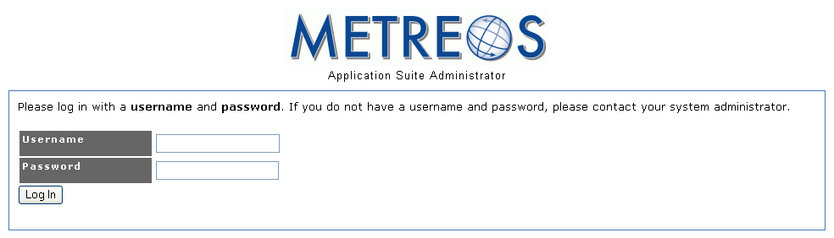
Figure 1. Signing On to Appsuiteadmin

- Select Edit Your Profile as shown on the following screen.
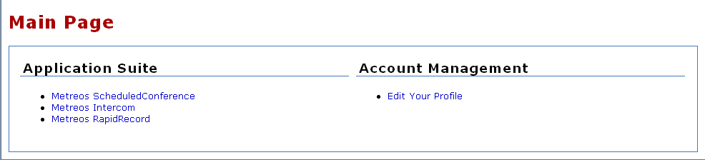
Figure 2. Editing a User Account
- Under Devices, select the Add Device button as shown in the following example. If you see no Devices section displayed, this means that the administrator has already configured this section for you, and you can skip ahead to the next section, Step 2. Configure Find Me Numbers.
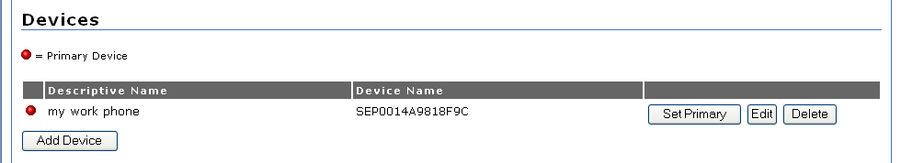
Figure 3. Adding a Phone Device
- Enter a descriptive name for the device in the Descriptive Name field.
- Check the IP Phone checkbox.
- Enter the MAC address of the phone in the Device Name field.
To access the MAC address for a Cisco IP phone, select the Settings soft key on the Cisco IP phone. Next, select Network Configuration and then MAC Address from the Cisco phone menu.
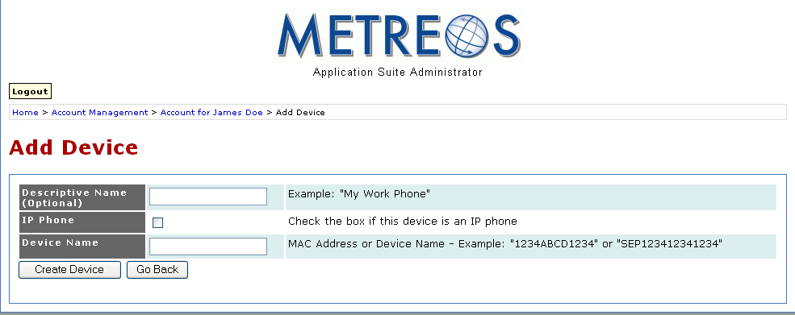
Figure 4. Creating a New Device
- Select the Create Device button.
- After you have created a device, ActiveRelay prompts you for the primary line number associated with the device as shown in the following screen. Enter a number here and select the Add Number button.
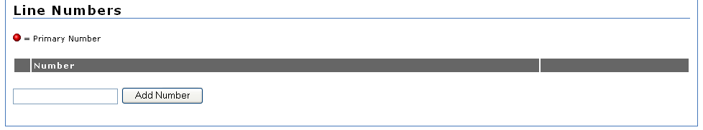
Figure 5. Entering the Primary Line Number
- ActiveRelay confirms that you have added your primary line number as shown in the following example. Verify that the number displayed on the screen is the number of your primary line.
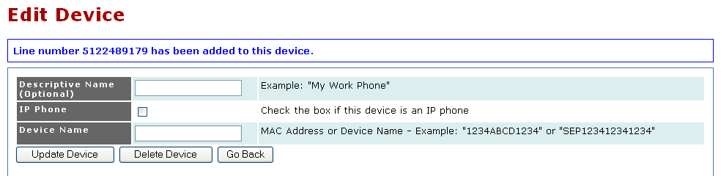
Figure 6. Verifying the Primary Line Number
- Step 2. Configure Find Me Numbers
Complete the following tasks to configure Find Me numbers. These are the numbers that ActiveRelay will dial when a call arrives at your office phone.
Procedure
- Go to http://<servername or IPaddress>/appsuiteadmin.
- Enter your username and password in the fields as shown on the following screen.
Figure 7. Signing On to Appsuiteadmin
- Select the ActiveRelay text link as shown on the following screen.
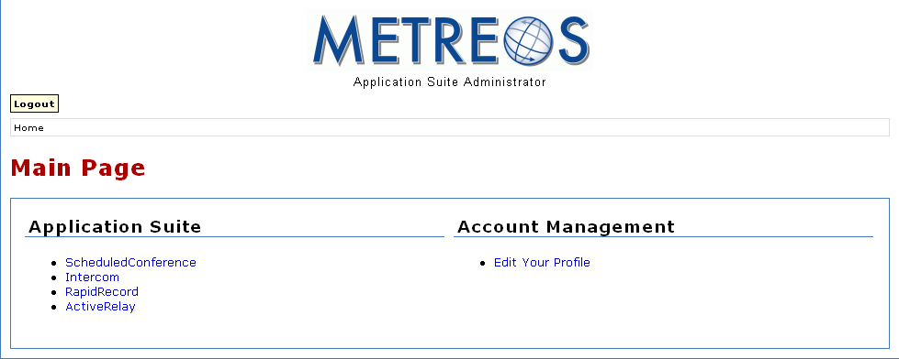
Figure 8. Editing a User Account
- Under Find Me Numbers, select the Add Number button as shown in the following screen.
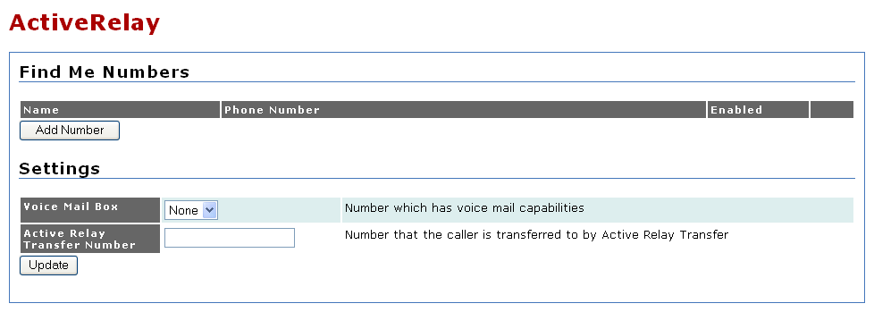
Figure 9. Adding Find Me Numbers
- On the Add Number screen, enter a descriptive name for the Find Me phone number as shown in the following figure.
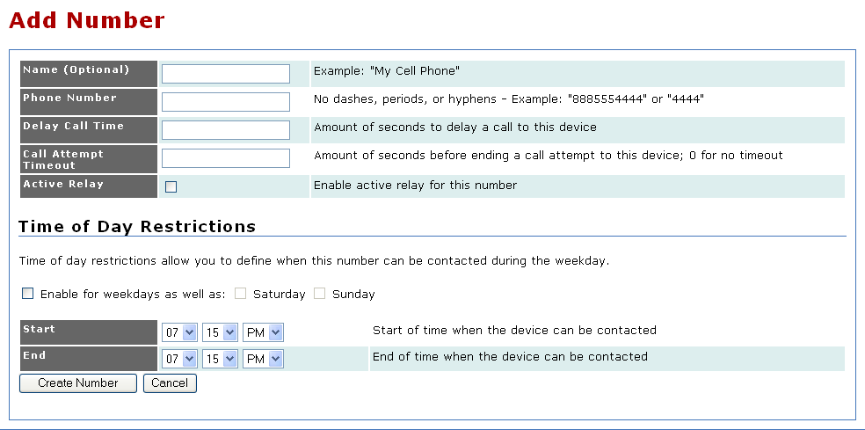
Figure 10. Configuring a Find Me Number
- In the Phone Number field, enter the number, formatted as 1 plus the area code and phone number, omitting punctuation; for example, 12065551212.
- In the Delay Call Time field, enter the number of seconds a call to this phone will be delayed after your office phone rings For example, you may need to specify a delay for your cell phone if you want to have a brief period in which to pick up your office phone before your cell phone begins ringing.
- In the Call Attempt Timeout field, enter the number of seconds after which the ringing of this number will stop. A value of 0 indicates to never abort the call.
- To enable or disable the ActiveRelay feature for this phone, check the ActiveRelay checkbox. You can enable or disable ActiveRelay for this phone at any time.
- Check the Enable for weekdays as well as checkbox to indicate that the number should ring Monday through Friday.
- To set the number to ring on Saturday and/or Sunday as well, check the appropriate checkbox.
- In the Start and End fields, enter the start and end time to specify that the number should only be called during certain hours. These values only take effect if the Enable for weekdays as well as checkbox is checked.
- Select the Create Number button when you have finished configuring the Find Me number. Your account profile will reappear. The following section can be found on this page:
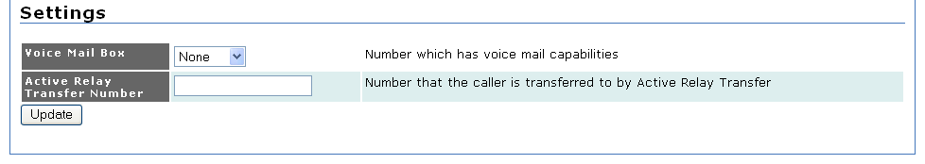
Figure 11. Setting the Voice Mail Box Option
If this is the number where you want to receive voice mail, select that number from the Voice Mail Box pulldown menu and select the Set button. Note that time of day routing will be applied to this number.
If you have an office IP phone which rings independently of your Find Me numbers, it is likely that this phone is configured for voice mail. ActiveRelay has no control over whether or not voice mail is routed to this phone. Therefore, when this is the case, configuring a Voice Mail Box for your account will result in the voice mail system which answers first taking the call.
- Step 3. Answer Calls Using ActiveRelay
After a phone call has been answered on an ActiveRelay Find Me number, the following options are available to you.
- Answer the call on the primary Find Me phone — answering a call on your office phone is the same with or without ActiveRelay configured. You simply pick up the phone to speak with the calling party.
- Answer the call on a non-primary Find Me Phone — when you pick up a non-primary Find Me phone, you must press the # key if you wish to accept the call. The call is then bridged through to your Find Me phone.

